**Assignment – 2: Master Mind Game**

COS10004 Computer Systems

Name: Kayes Ahmed Koushik

Student id: 103832293

**Solution:**

This is a game of mastermind that could be played between two people; one of the players is given the name code Breaker, while the other is given the name code Maker. I have done all the code together including stage 1,2,3. For maximum number I have used a function called maxguess. And I also implemented that my maxguess number that will ask under number 10.for max number I set a loop called checkmaxguess. I have no idea about stage 4 and stage 5.

**Here are some pictures of my code running down below:**

**Stage 01:**

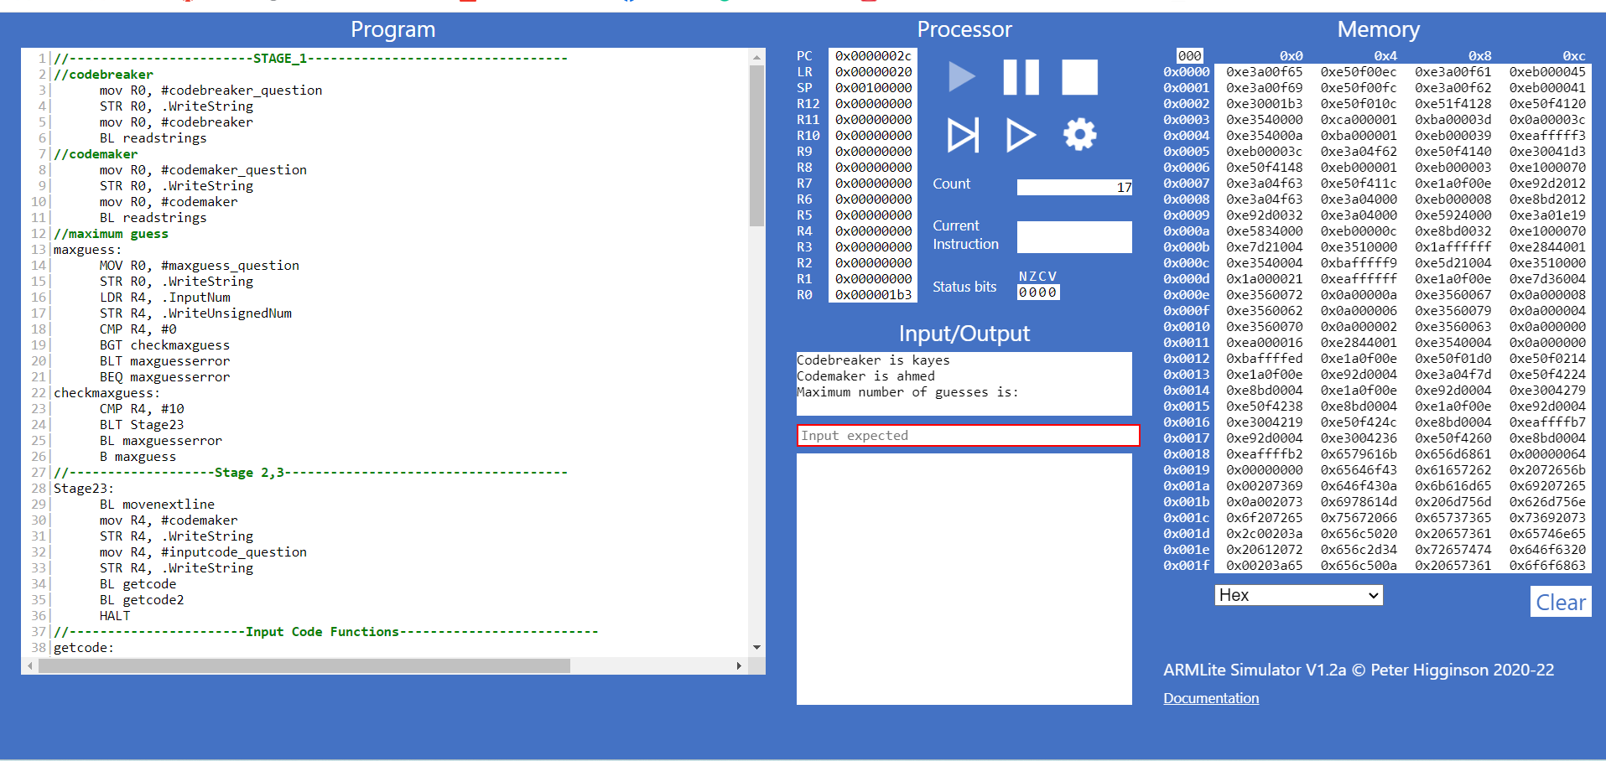

**Stage 02:**

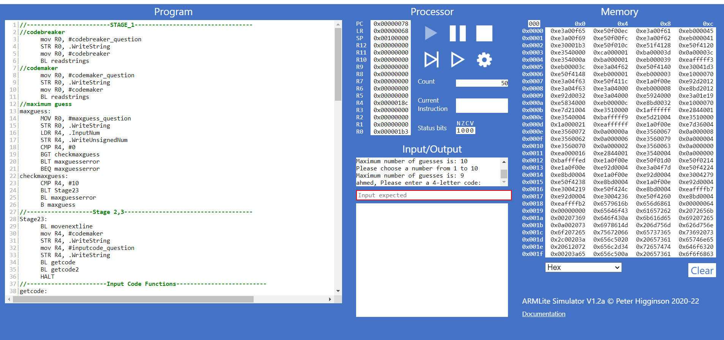

**Stage 03:**

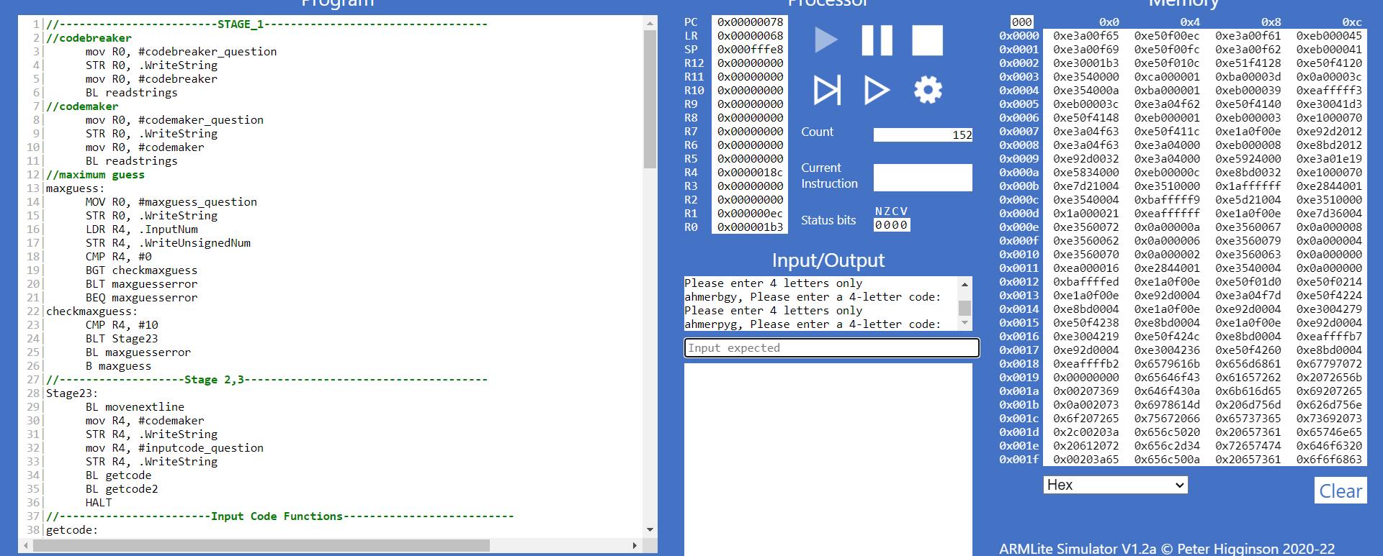

**Conclusion:**

That’s all I have figured out so far. I Couldn’t figure out the rest of the parts. Thank you.